Relative Adverbs

🔹 What Are Relative Adverbs?
# Source: AI Source: Provided by: [Data Path: Persons Table -> ID Column: 1, Name_En Column: Motasem Essam] -> From: [Chatgpt (GPT-4-turbo)] on [7/27/2025]
Relative adverbs are words that introduce a dependent clause (called a relative clause) and connect it to a noun or pronoun in the main clause.
They work like relative pronouns, but instead of referring to people or things, they refer to time, place, or reason.

✅ Common Relative Adverbs
# Source: AI Source: Provided by: [Data Path: Persons Table -> ID Column: 1, Name_En Column: Motasem Essam] -> From: [Chatgpt (GPT-4-turbo)] on [7/27/2025]
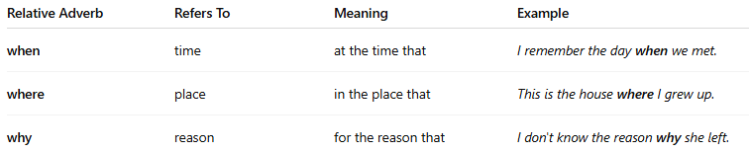
Relative Adverb | Refers To | Meaning | Example
when | time | at the time that | I remember the day when we met.
where | place | in the place that | This is the house where I grew up.
why | reason | for the reason that | I don't know the reason why she left.

📚 Examples in Sentences
# Source: AI Source: Provided by: [Data Path: Persons Table -> ID Column: 1, Name_En Column: Motasem Essam] -> From: [Chatgpt (GPT-4-turbo)] on [7/27/2025]
- That was the year when I graduated.
- This is the park where we used to play.
- Do you know the reason why he’s upset?

🧠 Key Notes
# Source: AI Source: Provided by: [Data Path: Persons Table -> ID Column: 1, Name_En Column: Motasem Essam] -> From: [Chatgpt (GPT-4-turbo)] on [7/27/2025]
- They introduce a relative clause and modify the noun before them.
- They are not asking questions — they are joining clauses, unlike interrogative adverbs.
- The clause they introduce often gives more information about a noun.

